**Math Reviewer**

**Geometry**

* **Geo**: “Earth”
* **Metri**: “Measurement”
* **Euclid** – Father of geometry around 300BC.

**Definition:**

1. **Definition** – Statement clarifying the meaning of a word or a phrase.
2. **Space** – Set of all points.
3. **Coplanar Points** – Points on the same plane.
4. **Collinear Points** – Points on the same line.

**Three Ways of Describing a Set:**

1. **Point -** has no length, no width, and no thickness.
2. **Line** - has infinite length but has no width and thickness; is straight.
3. **Plane** - has infinite length and width, but no thickness; is a flat surface.

**Subsets of a Line:**

1. **Collinear Points** - Are points that are contained in one line.
2. **Segment** - Portion of a line that has two endpoints.
3. **Ray** - Portion of a line that has one endpoint.
4. **Opposite Rays** - Two rays having a common endpoint and lie on a line.
5. **Coplanar Points** - A set of points that lie on one plane.

**Collinear Points:**

1. **Distance** - The distance between two points P and Q is the absolute value of the difference of the coordinates of the two points.
2. **Coordinate** - The number that corresponds to a point.
3. **Betweenness** - a point Q is between P and R if (a) P, Q, and R are collinear points and

(b) PQ + QR = PR

1. **Midpoint** - R is the midpoint of PQ if (a) P, Q, and R are collinear points and (b) PQ + QR = PR
2. **Segment Bisector** - Any ray, segment, or line that passes through the midpoint of a segment.
3. **Congruent Segment** - Segments with the same length.

**Angle Pairs:**

1. **Congruent –** If two angles are having the same measurement.
2. **Supplementary** - If the sum of two angles measurements is at 180° in total. Each angle is

called a supplement of the other.

1. **Complementary** – If the sum of two angles measurements is at 90° in total. Each angle is

called a complement of the other.

1. **Adjacent angles** - are two coplanar angles that have a common side between them but have no interior points in common.
2. **Linear Pair -** If two angles are adjacent and supplementary.
3. **Vertical Angles** - are non-adjacent angles formed by two intersecting lines.
4. **Angles at a Point** - All angles having the same vertex around a point.

**Angles:**

|  |  |  |
| --- | --- | --- |
| **Terms** | **Illustration** | **If-then Form** |
| **Acute Angle** - An angle whose measure is less than 90° |  | If ∠A is an acute angle, then m∠A < 90°. |
| **Right Angle -** An angle whose measure is equal to 90°. It can also be defined as an angle whose sides are perpendicular. |  | If ∠A is a right angle, then m∠A = 90°.  If ∠A is a right angle, then  AB ⟂ AC. |
| **Obtuse Angle -** Is an angle whose measure is more than 90° |  | If ∠A is an obtuse angle, then m∠A > 90°. |

**Symbols:**

|  |  |
| --- | --- |
| **Name of Symbols** | **Symbols** |
| **Intersecting:** |  |
| **Perpendicular:** |  |
| **Parallel Lines:** |  |
| **Concurrent Lines:** |  |
| **Parallel:** |  |
| **Segment:** |  |
| **Line Segment:** |  |
| **Ray:** |  |
| **Congruent:** |  |

**Angle Properties:**

|  |  |  |
| --- | --- | --- |
| **Angle Properties** | Illustration | If-then Form |
| **Congruent**: If they have the same measure. |  |  |
| **Supplementary Angle(s)**: If the sum of their measures is 180° in total. Each angle is called a supplement of the other. |  |  |
| **Complementary Angle(s)**: if the sum of their measures is 90°. Each angle is called a complement of the other. |  |  |
| **Adjacent Angle(s)**: Two coplanar angles that have a common side between them but have no interior points in common. |  |  |
| **Linear Pair**: Two adjacent angles and are supplementary (180°). |  |  |
| **Vertical Angles: N**on-adjacent angles formed by two intersecting lines. |  |  |
| **Angles at a Point**:All angles having the same vertex around a point. |  |  |



**Parallelism:**

* The state of being parallel or of corresponding in some way.

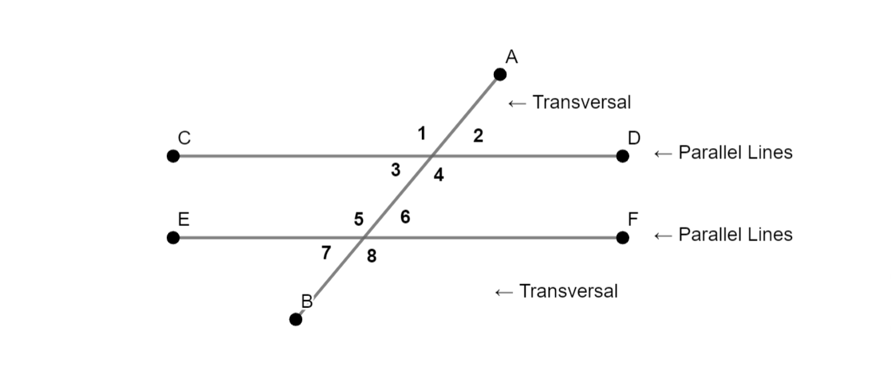

* **External Angles:**

∠1 and ∠2

∠7 and ∠8

* **Internal Angles (Supplementary:**

∠3 and ∠4

∠5 and ∠6

* **Corresponding Angles (Congruent)**:  
  ∠1 and ∠5

∠3 and ∠7

∠2 and ∠6

∠4 and ∠8

* **Vertical Angles:**

∠1 and ∠4

∠2 and ∠3

∠5 and ∠8

∠6 and ∠7

* **Alternate External Angle (Congruent):**

∠1 and ∠8

∠2 and ∠7

* **Alternate Internal Angles (Congruent):**

∠3 and ∠6

∠4 and ∠5

**Addition of Polynomials**

* Sum of (3x + 4) + (7x – 8) = 10x – 7

[Steps]

3x + 4

7x – 8

10x – 7

* Please note that you should follow to bigger number for the sign (to the left specifically)
* The value can change from positive to negative if there is an untouched minus sign behind the number.
* Commutative: a + b = b + a
* Associative: (a + b) + c = a + (b + c)

**Subtraction of Polynomials**

* Difference of (5x + 4) – (7x + 2) = 11x + 2

[Steps]

5x + 4

7x + 2

11x + 2

* The best method to subtraction polynomials is to: make the operation addition but make all the bottom (not including top) numbers negative.
* To subtract an expression from another expression, add it’s negative. That, is:

a – b = a + (-b)

* It is very similar to integers.

**Bases and Exponents**

1. Natural Number Exponent

* If n is a natural number, then xn (x is the base, n is the exponent)

1. – (9 * 9 * 9 * 9 * 9 * 9 * 9) = -97
2. ab * ab * ab * ab * ab = (ab)5

* Note that it is (ab)5 because if it is “ab5,” only the variable “b” has the exponent.

1. 23 * 22 = 25
2. 34 * 33 = 37

**Laws of Exponent**

1. Product Rule for Exponent

* If m and n are natural numbers, then xm * xn = xm+n

1. a3 * a5 = a8
2. (9b3) (3b6) = 27b9
3. 5y2 * y6 = 5y8
4. Power Rule of Exponent

* If m and n are natural numbers, then (xm)n = xmn

1. (x3)2 = x6
2. (x2)5 = x10
3. Product to a Power Rule for Exponents

* For any factors, x and y and integer exponent n: (xy)n = xn yn

1. (ac)5 = a5 c5
2. (x2 y)4 = x8 y4
3. (-4e5 f)3 = -64e15 f3
4. Quotient Rule for Exponent

* If m and n are natural numbers, and m > n and x ≠ 0 then:

Xm / xn = xm--n

1. y6 / y2 = y4
2. j10 / j2 = j8
3. 81x2 / 9x = 9x
4. Quotient to a Power Rule for Exponents

* For any divided x, non-zero divisor y, and integer exponent m:

(3a / b)3 = 33a3 / b3 = 27a3 / b3